HYDRAPOWER INSTALLS 2000 TON X 50’ PRESS BRAKE

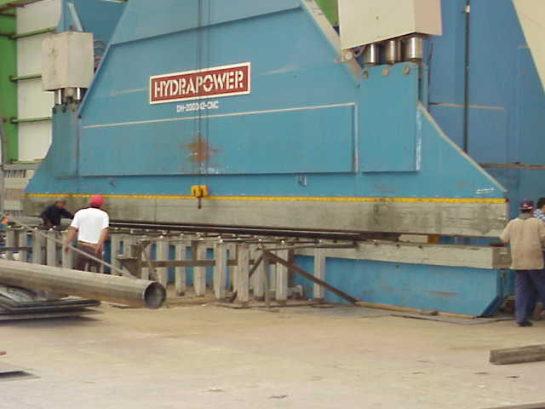

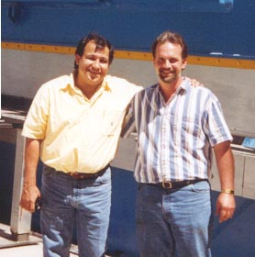
After almost 2 years on 2 shifts our HYDRAPOWER 2000Ton press brake has made over 25,000 tower poles.
We have run continually with no down time,
reports Abel Vega Maintenance Manager-
Polesa, Guadalajara,, Mexico.

We also have Hydrapower 1000 Ton x 50’, a 1200 Ton x 60’ and 600Ton x 30’ machines.

